IILES ©

CITY
ORTH

PALISADES BLVD

- Shoulder Widening ""- and Resurfacing
...... New Rumble Strips
•••
+++ Water and Sewer
I
Select ..1id0walk and ADA Curb
  - Ramp Improvements (both sides)
- Roadway Reconstruction

Detour Route
- - Overlay on Detour Route
@ Miles City Airport
@ Bender Park
@ Bridge

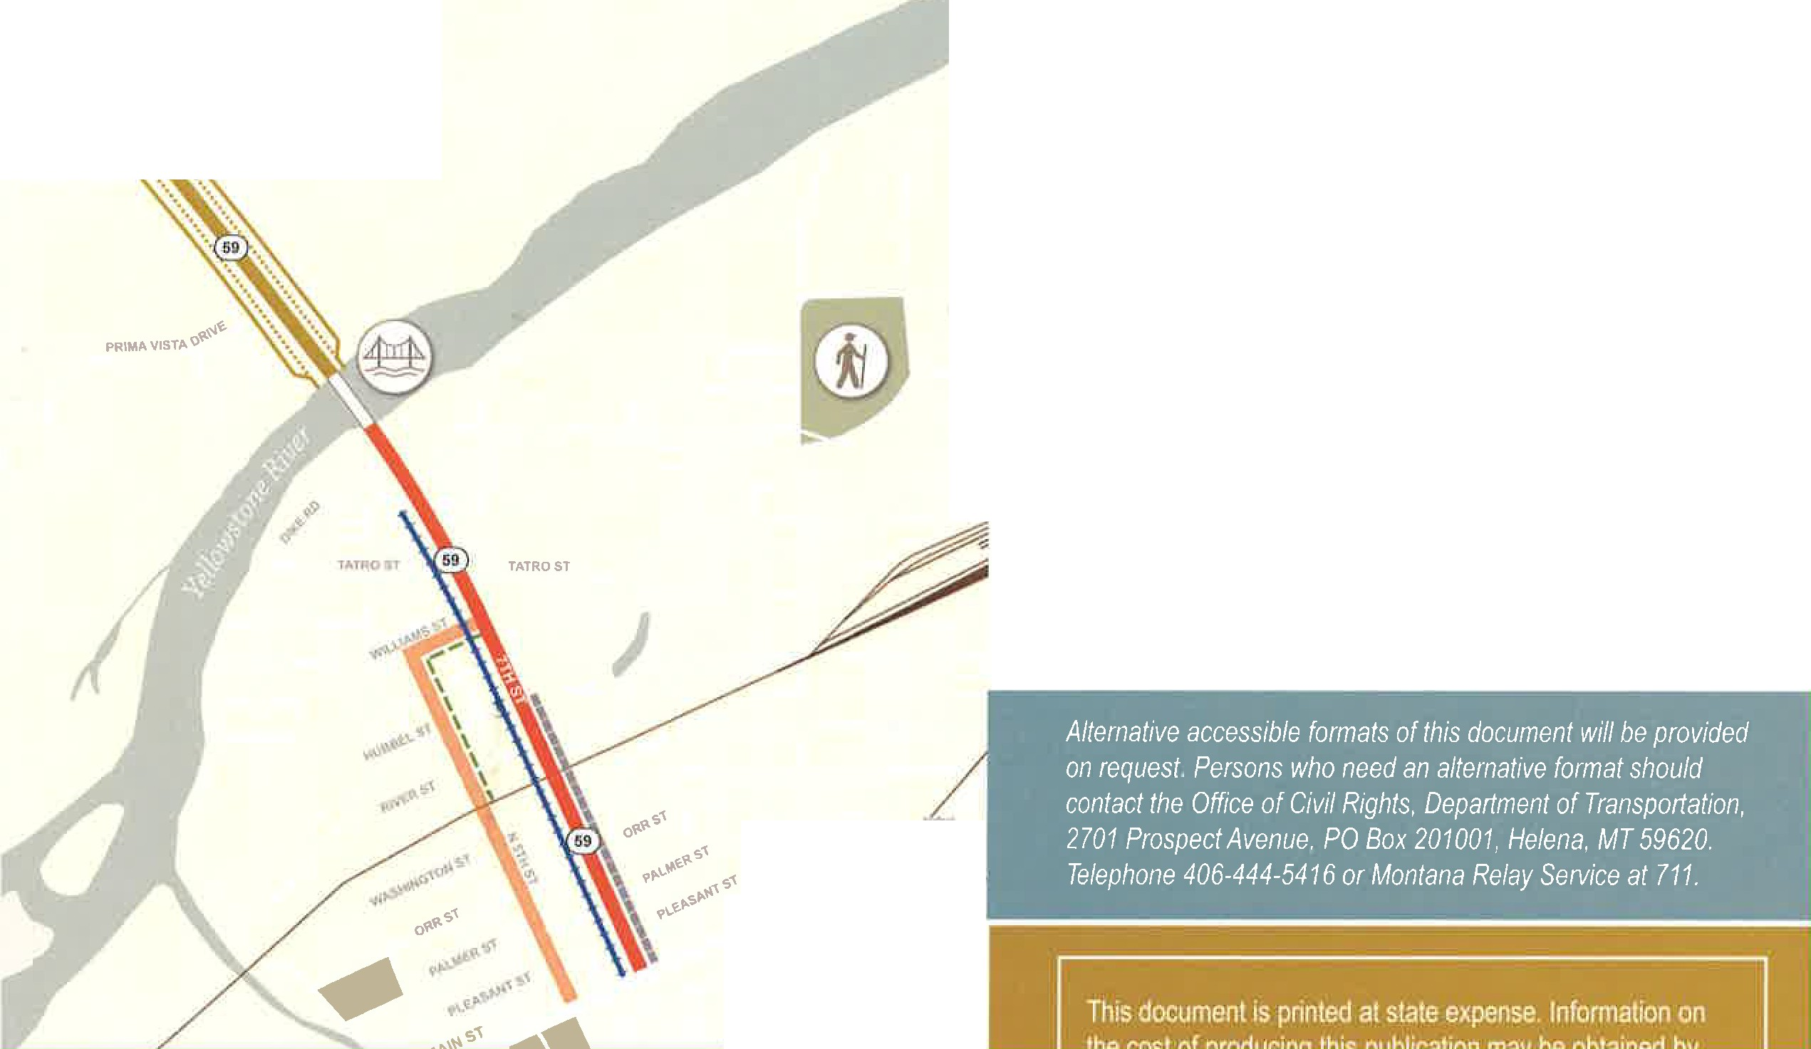

Project Contact Information

https://mdt.mt.gov/pubinvolve/milescitynorth

888.242.7770

milescitynorth@dowl.com
.
/ MIU
/

